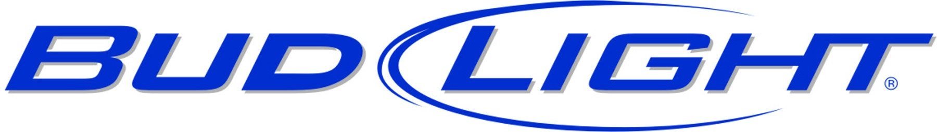
THE 19TH ANNUAL
LANIKAI COLDPACK CLASSIC



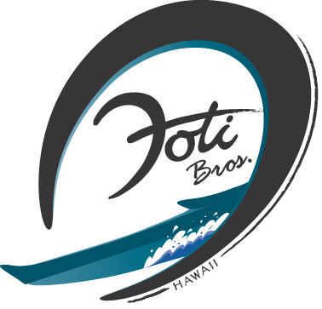

Saturday, December 17, 2011

COURSES: Subject to change with weather

SHORT – Approximately 3.5 miles inside Lanikai reef and the Mokulua Islands.

LONG – Weather pending: From Lanikai Canoe Club paddling site, the course heads towards Waimanalo to Wailea Point, then rounds the Mokulua Islands, the Weather Buoy and Flat Island, then finish back at LCC paddling site (appx. 6 miles). SUBJECT TO CHANGE

DIVISIONS: OC-1, OC-2, SUP, Surfski, etc... Novice, Juniors, age groups (18-29, 30-39, 40-49, 50-59, 60+), Open. (OC-2 divisions - add ages and divide by two for your category).
NEW: GECKO KEIKI DIVISION! Under 12 years old. Age categories according to participation. Short triangle course approx. 200 yards. Knock out format. Gecko Keiki canoes provided if your keiki doesn't have one of their own.

REGISTRATION: Begins at 8:00 a.m.

PARKING: Inside Lanikai Park
START TIMES: 10:00 a.m. – Gecko Keiki Division
11:30 a.m. – Men and Women Short and Long. NOTE: This year men AND women race together
1:30 p.m. - Lunch & Awards

ENTRY FEE: $20 and a Cold Pack of your favorite beverage for the canoe cooler. Keiki under 12 free!


